Wallingford Deanery Synod: Summary 2024
(prepared by Ali Adams, Deanery Synod Secretary)

The Deanery includes parishes in Blewbury, Brightwell-cum-Sotwell, Chilton, Cholsey, Crowmarsh Gifford, Didcot, Great Western Park, Hagbourne, Harwell, Moulsford, the Moretons, the Astons, Upton, Wallingford.. The Deanery Synod provides PCCs with an important link between parishes and the wider structures of the church. Meetings are jointly chaired by the Area Dean (Revd Dr Andy Lord) and Lay Chair (Vaughn Lawfull).

- Two Deanery Synod meetings and two Standing Committees were held in 2024. The Synods both related to the question of how we perceive ‘church’ in the modern world.

The first Deanery Synod meeting in February heard from Revd Pete Wheeler from St Peter’s Aylesbury (who is on the Diocesan New Congregations Board), speaking about the church he ministers at on a rather deprived estate. He explained that his church has gone through a period of revitalisation – a few elderly folk ran the church on the estate, effectively forming a ‘club’ while concentrating on fundraising. Pete encouraged a ‘breakfast church’ to introduce health/well-being and to inspire families to choose things for themselves. On the first Sunday an 11 year old turned up, on the second he brought his brother, on the third they brought their mother. 4-5 years later there are 80-90 each Sunday, of whom 80-90% are unchurched. All activities are intergenerational - attendees bring their own food and a different culture. They also bring problems of addiction, abuse, alcoholism, but God is at work breaking chains.

Pete talked through several principles of creating a healthy church:
- Mission is not a department – it runs through our activities… His church has no intention of inviting people in – they need to want that themselves
- Church is usually an attractional model (expect others to come to you) but we need it to be an incarnational model (expect to go to them)
- ‘Appreciative Enquiry’ is the principle that everything we need to grow and thrive is already in the room/in our hands. We need to think about Asset Based Community Development (the ABCD concept). We should ask our PCCs about what we actually already have
- We need to consider what our Mission Statement is/should be

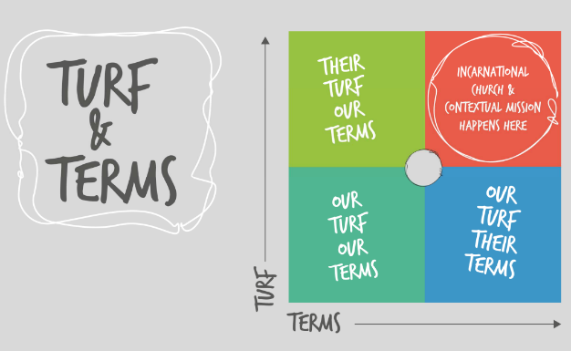

Between the first and second Synods, the Area Dean was on sabbatical for just over three months, focussing particularly on the theology of creation.

The second Deanery Synod meeting in November was addressed by Revd Canon Helen Kendrick who had been asked to comment on ‘The Church in Mission’ from her experience in the Damascus group of parishes: Helen took as her theme the stories told in Acts of new congregations sharing together/numbers growing as others were saved. The Damascus parish covers 5 villages which from being 5 different entities until WW2, have now grown into large places bordering Abingdon and Didcot Garden Town. Helen has been there for 21 years, in which time the congregations have halved. In 2017 a radical decision was made to become a single parish – not an easy process (there were 26 different bank accounts!) but activities such as sorting out paperwork and joining the Parish Giving Scheme has helped stewardship, numbers are now growing and the parish has a financial surplus. There is basically one PCC with churchwardens plus local church committees with Co-wardens, and one general fund. Pastorally, there is a key person in each church who calls in members of the clergy when required – they are building up lay teams to become the central contacts. Technology is being enabled in new ways – moving more and more data into Google programs. Practically, church worship moves around between the villages, but each church is unique.

The group’s Mission Statement is ‘nurturing faith, bringing hope, sharing love’. From a PCC Away Day came the idea of ‘5 doors’: using all of the 5 main church buildings. There are home groups, lay-led services, the use of ‘Open the Book’ in the primary schools, an assembly in each school weekly. Warm Spaces, emergency food supplies, toddler groups, family engagement afternoons. They encourage regular giving of talents as well as money. Helen reminded us that if everything else seems impossible – keep praying!

There was time for discussion in small groups and a Q&A. These clarified some of the missional and structural issues faced by parishes and Benefices in the Wallingford Deanery. There was plenty to think and reflect further on!

- At both synods there were discussions about (and commitments to) Parish Share Payments. At the end of 2024 the Deanery had raised £468,341, a significant sum, towards the Share allocated to it.

- Gordon Gill stood down as Lay Chair at the beginning of the year and was gratefully thanked for all he had contributed during his years in office. Vaughn Lawfull was voted in as his successor in that role in November. Due to the continued lack of a Deanery Treasurer, the Standing Committee has covered this role again this year.

- The Deanery Secretary ran the Diocesan Election process in the Deanery during the Area Dean’s Sabbatical (and during the vacancy for Lay Chair). Revd Jason St John Nicolle was elected to one of the two Clergy vacancies; but one Clergy and two Lay places were not filled.

- Each Synod heard a report from Professor Helen King in her role as a General Synod Representative, particularly in relation to the Living in Love & Faith process, and to the many aspects of Safeguarding which had featured in the national news during the year.

Inspections took place in several parishes during 2025 particularly in the Churn Benefice – more will take place in 2025 lessening the backlog after the hiatus of the pandemic.

Much work took place around the Deanery on projects related to Children & Youth, ahead of a plan being put together in 2025 alongside the diocesan bid for national funding. It was very encouraging to hear stories of so many varied activities taking place each month right across the Deanery.

