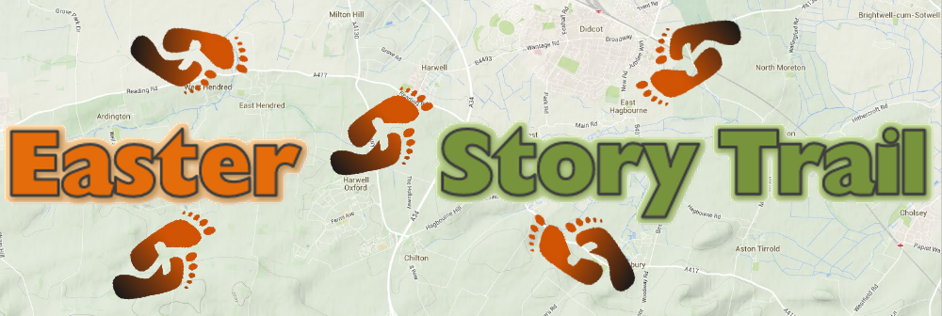
Well done on finishing the trail and cracking the code!

Answer: __ __ __ __ __ __ __ __ __ __ __ __ __ __

Name:

Phone number:

